Test Case – Purchase Oil from Ensek Energy Corp as a new user

Steps

1 – Go to Url - <https://ensekautomationcandidatetest.azurewebsites.net/>

Expected result – User is directed to the home page of the Ensek Energy Corp

Actual result - User was directed to the home page of the Ensek Energy Corp

PASS

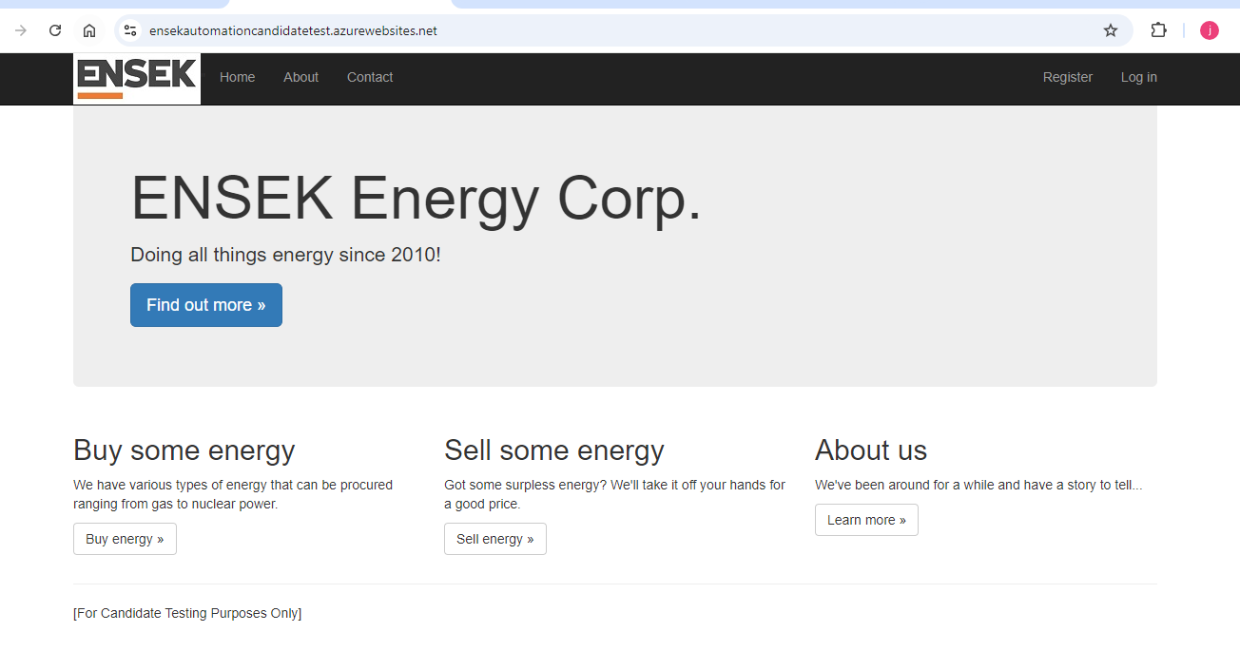

2 – Select the Register button at the top right of the screen.

Expected result – When the user clicks the button, they are directed to the Register page

Actual result - When the user clicked the button, they were directed to the Register page

PASS

3 – Populate the fields – Email Adress, Password, Confirm Password

Expected result – The fields should be populated with the email and password

Actual result – The fields were populated with the email and password

PASS

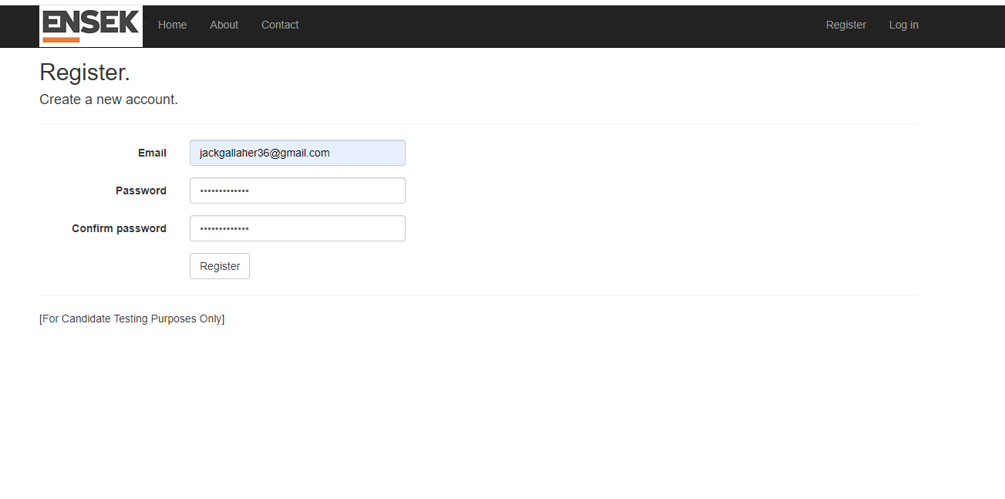

4 – Select the register button

Expected result – The user is now signed up the website.

Actual result – The screens is stuck loading for a long time and the user receives an error message. The message states that there was an issue connecting to the SQL server.

FAIL

Defect logged – User is unable to register as a new user

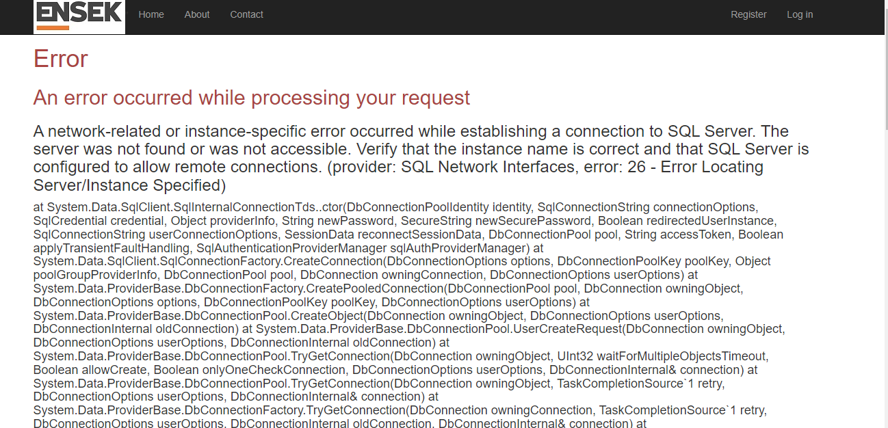

Notes - In order to progress further with the test, the team tested the remainder of the test without logging in to see if the functionality for buying energy works.

5 – Return to the home page

Expected result – The user is now on the home page.

Actual result – The use was directed to the home page

PASS

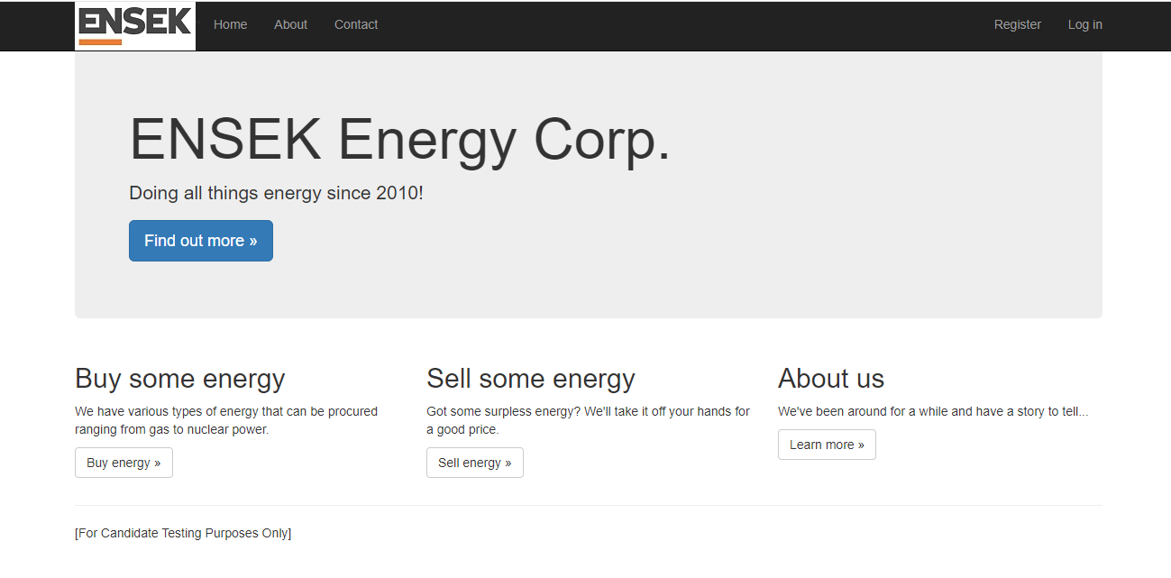

6 – Select Buy Energy button

Expected result – The user is now on the Buy Energy page.

Actual result – The user was directed to the Buy energy page

PASS

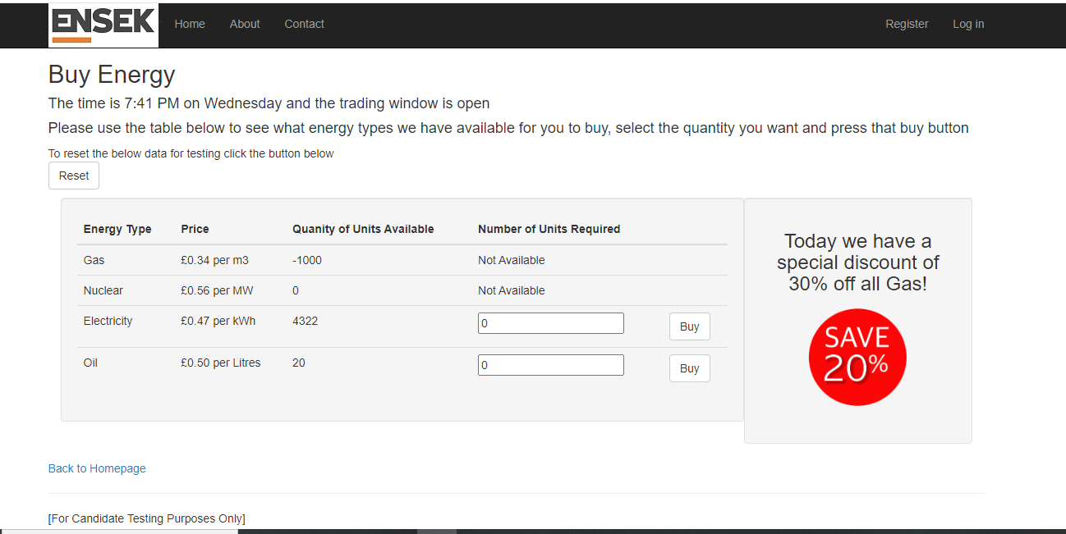

Other defects spotted on the page

Defect – The Special offer message says its 30% off and save 20%. It should say save 30%

Defect – The time for the trading window is incorrect. It keeps increasing by 2 mins instead of 1 min

7 – Populate the Number of units for Gas as 4000

Expected result – The Number of Units field for Gas should be populated with 4000

Actual result – The Number of Units field for Gas should is populated with 4000

PASS

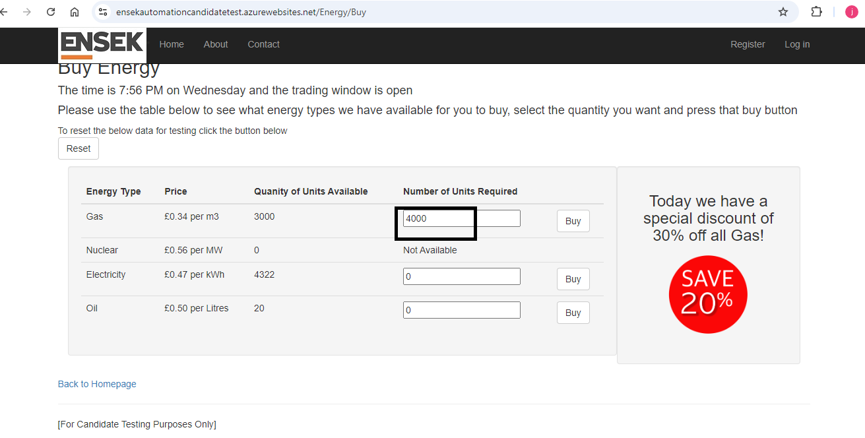

8 – Select ‘Buy’

Expected result – I should not be able to buy any gas because there was only 3000 units available

Actual result – User has purchased the gas they requested, and the remaining amount is now -1000

FAIL

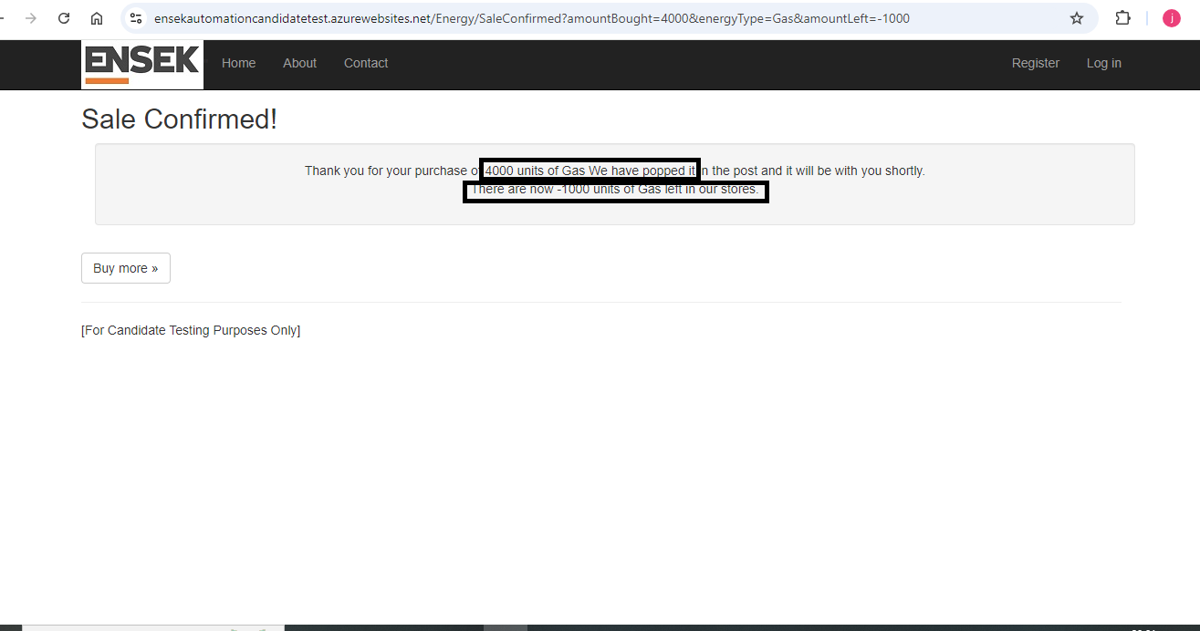

Defect logged – Users can buy more units than there is left over. i.e. purchase 4000 units but there are only 3000 units left.

9 – Select Buy more button

Expected result – The user is now back on the Buy energy page

Actual result – The user was directed back to the Buy energy page

PASS

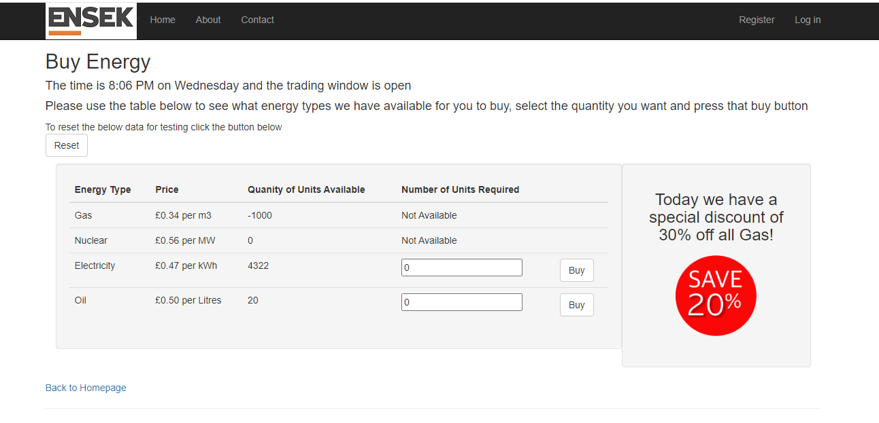

Defects logged below with Priority to fix and severity

Defect logged – Users can buy more units than there is left over. i.e. purchase 4000 units but there are only 3000 units left.

Severity – High

Priority – 1

Defect – The time for the trading window is incorrect. It keeps increasing by 2 mins instead of 1 min

Severity – High

Priority – 2

Defect – The Special offer message says its 30% off and save 20%. It should say save 30%

Severity – Low

Priority – 2

Defect logged – User is unable to register as a new user

Severity – Critical

Priority – 1